EXP1: 8 Puzzle Problem

Name: Y. Roshitha (192424400)

Aim:
To develop a Python program that solves the 8-Puzzle (Sliding Puzzle) problem using the Breadth-First Search (BFS) algorithm and displays the sequence of steps required to reach the goal state.

Algorithm:
Step 1: Start with the initial puzzle state (3x3 matrix with one blank represented as 0).
Step 2: Check if the current state is the goal state.
Step 3: Find the position of the blank tile (0).
Step 4: Generate all valid neighboring states by moving the blank tile:
- Up
- Down
- Left
- Right
Step 5: Add all unvisited neighboring states to the BFS queue.
Step 6: Mark the current state as visited.
Step 7: Repeat Steps 2-6 until the goal state is found.
Step 8: Return the complete path from the initial state to the goal state.

Source Code:
from collections import deque

# Initial and goal states
initial = (
(1, 2, 3),
(4, 0, 6),
(7, 5, 8)
)

goal = (
(1, 2, 3),
(4, 5, 6),
(7, 8, 0)
)

def find_blank(state):
for i in range(3):
for j in range(3):
if state[i][j] == 0:
return i, j

def get_neighbors(state):
neighbors = []
x, y = find_blank(state)
directions = [(-1,0),(1,0),(0,-1),(0,1)] # up, down, left, right
for dx, dy in directions:
nx, ny = x + dx, y + dy
if 0 <= nx < 3 and 0 <= ny < 3:
new_state = [list(row) for row in state]
new_state[x][y], new_state[nx][ny] = new_state[nx][ny], new_state[x][y]
neighbors.append(tuple(tuple(row) for row in new_state))
return neighbors

def bfs(initial, goal):
queue = deque()
queue.append((initial, []))
visited = set()

while queue:
state, path = queue.popleft()
if state in visited:
continue
visited.add(state)
path = path + [state]

if state == goal:
return path

for neighbor in get_neighbors(state):
if neighbor not in visited:
queue.append((neighbor, path))
return None

solution = bfs(initial, goal)

print("Steps to solve the 8 Puzzle:\n")
step = 1
for state in solution:
print("Step", step)
for row in state:
for value in row:
print("_" if value == 0 else value, end=" ")
print()
print()
step += 1

Flowchart:

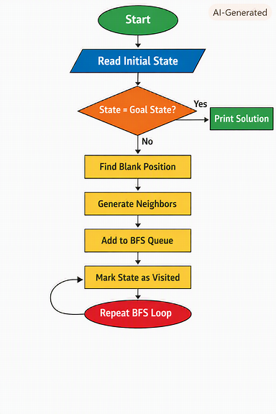

Output:

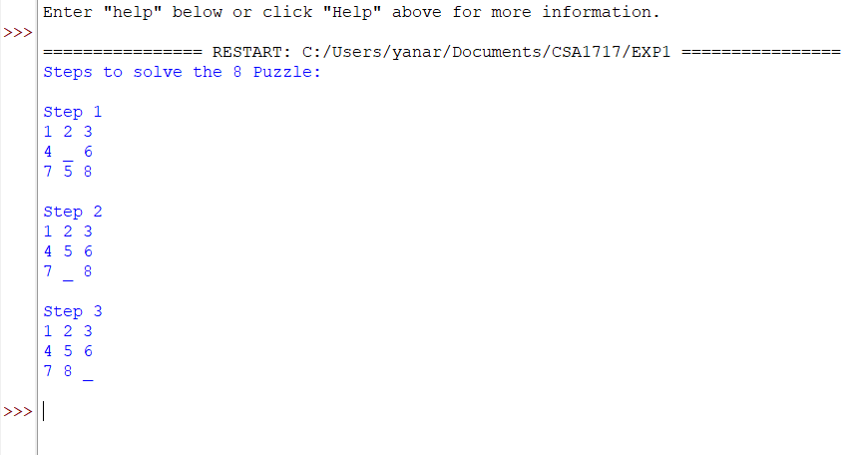

Result:
The 8-Puzzle program successfully solved the given initial puzzle configuration using the Breadth-First Search (BFS) algorithm. The program generated all possible valid moves by sliding the blank tile and explored each state level-by-level until it reached the goal state.
During execution, the program displayed every intermediate step clearly. At each step, the blank tile (0) was moved either up, down, left, or right to bring the puzzle closer to the goal arrangement. Finally, the program reached the goal state where all the tiles were arranged in the correct order and the blank space was positioned at the last cell.
Thus, the 8-Puzzle Problem was solved successfully using the Breadth-First Search (BFS) algorithm.

